1. For all forms the Arabic names fields: “should not be required to fill”

--Pending

1. When Page Saved a new account is created in the name of the bank and branch under Current Assets.

Ok but should be saved under CASH inside Current Assets “ not Others”

- -Done

* In account chart when add new account and add account balance:

We should add (+) or (-) to know it is debit (+) or Credit (-)

You can use negative values

1. Daily Journal “of course the most important pages”:

* Change name of “Serial No to Reference No” and allow edit. --Done
* Add date cell and allow to edit



* The DropBox for choose the account:
* Show the accounts as its ordering in the account chart. –Done

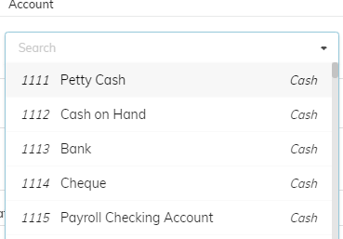

* The level 3 like (111,112…) should not apper in that dropBox because it’s a groups not accounts and should not do any financial action on it. --Done
* Search with account code not working please test. – Done

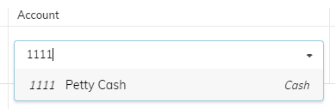

* Cost center in the form should be last entry and allow fill or not fill

--Done

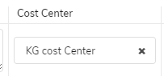

note: you can click the little “X “icon to clear the cost center if you want it empty

* Description increase cell size for it, and the words which I insert in the first textbox should copy to the second and copy to description automatically and allow edit.
* Done with advanced features

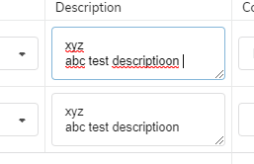

Note: The Size of the description is increased and the words inserted will be automatically copied to other description from the first description

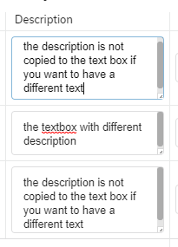

Note : If you want to have a different description you can simply change the description it will not affect from the first description.

* In Credit and Debit should not write any digit’s numbers and the system know if the amount credit or debit.

--Done

* Statement is not mandatory and remove statementAr

--Done

* Operation Description text change to Cost Center Description and not mandatory

--Done

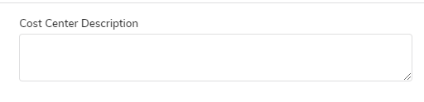

**Ledger Report**

1. The whole page is redesign with quick dropdown list and new layout. --Done

2. Can show report on professor account (General Ledger) --Done

3. Professor account is showed in red color click to see report on professor account. --Done

4. Ledger report for Cash Account --Done

**Student Module**

1. Grades Fee Configuration … change to …. Setup Grades Fees --Done
2. Tax is not changed for each Grades it is static percentage and should be same for all grades and all other fees. – Done



Note: Tax has been removed in all and will remain same for all the grades and tax will be added to fiscal year

1. We need a gridview like :

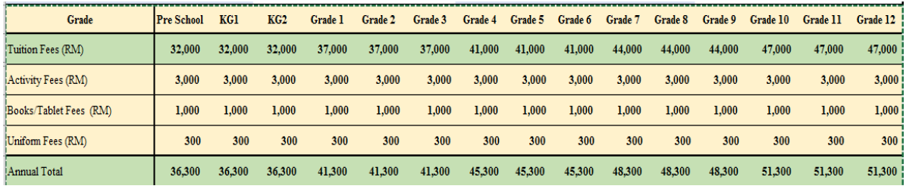

This gridview will saved in the beginning of new year

Note: Due to the complexity of the fee setup form, it cannot be made editable as a grid view

And hence this feature is added as a report displaying all the fees of grades

Follow these steps for the report

1. Go to **Setup Grades Fee** under **Students**
2. Select Study Year from the drop-down list
3. And click Get Fees Report button



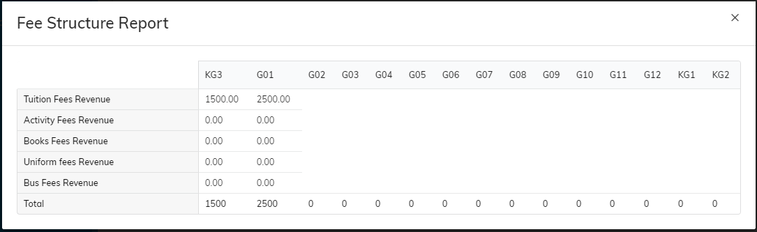

**Note: the type of fees is selected automatically from the**

**Account chart under Revenues sub account. Note only account**

**name ending with Fees Revenue will be shown inside grade fees**

**configuration.**

* Change Iqama to visa

--Pending

* Add more details to the students registration about Father and mother:

Name Job email Tel Address children account --Pending

* Can attached old certificates --Pending

**I can’t find this section:**

**This section is already present click the student academic id in the student page**

**NOTE: The purchase tab is not fully functional because the inventory module is not been requested and finalized as per the client’s requirements rest every thing is working fine**

**P.S: Some of the pending points is also finished but has not been published**

**Will be informed ASAP Once tested and published.**

